ASSIGNMENT-4

|  |  |
| --- | --- |
| **Assignment Date** | 07 November 2022 |
| **Student Name** | Bismi Majidha S |
| **Student Register Number** | 950819104012 |
| **Maximum Marks** | 2 Marks |

# Question 1:

Pull an Image from docker hub and run it in docker playground.

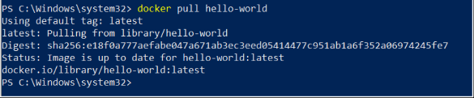

# Question 2:

Create a docker file for the job portal application and deploy it inDockerDesktop Application

FROM

h e l l o

w o r l d

:

l a t e s

t W O R K D I R

~

/ D

e s k

t o p

/

A D D

.

h e l l o w o r l d

/

W O R K

D I R

~/Desk top/ht mlfile

RUN pip install -rrequirements RUNchmod +x app.sh CMD ["/bi n/sh","app.sh"]

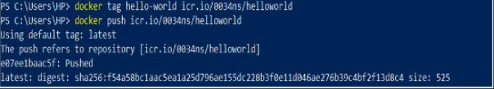

# Question 3:

Create an IBM container registry and deploy helloworld app or Job portal app.

# Question 4:

Create a Kubernetes cluster in IBM cloud and deploy helloworld image orjob portal image and also expose the same app to run innode port.

